**[Project title]**

**PROJECT**

**CYB292**

**Cyber Security**

**Supervisor: [professor’s name]**

**Presented by:**

**Student 2 Name**

**SID #**

**Student 1 Name**

**SID #**

**Student 4 Name**

**SID #**

**Student 3 Name**

**SID #**

**Student 5 Name**

**SID #**

**Academic Year 1445 AH**

**REPORT STRUCTURE AND CONTENT GUIDELINES**

Abstract

Table of contents

List of Figures

List of tables

List of abbreviation

**GENERAL INTRODUCTION**

1. Context

2. Problem statement

3. Main contributions

4. Manuscript organization

**CHAPTER I. BACKGROUND & PRELIMINARIES**

1.1. Introduction

1.2. Project Domain and Motivations

1.3. Problem definition

1.4. Overview of existing systems

1.5. Challenges and objectives

1.6. Solution overview

1.7. Project planning

1.8. Chapter summary

**CHAPTER II. SOLUTION DESIGN**

2.1. Introduction

2.2. System architecture

2.2.1 Architecture overview

2.2.2. Technical details

2.2.3. System components

2.2.4. Data handling and security considerations

2.3 Chapter summary

**CHAPTER III. VALIDATION**

1. Introduction

2. Hardware and software environment

3. Prototype implementation and deployment

4. Testing/Interfaces

5. Case studies and scenarios

6. Chapter summary

SUMMARY

1. Objectives revisited

2. Challenges and future work

REFERENCES

APPENDICES

**GENERAL INTRODUCTION**

In the realm of cyber security, log analysis serves as a cornerstone for identifying potential threats, detecting anomalies, and ensuring the integrity of computer networks. This project delves into the domain of log analysis, focusing on leveraging machine learning algorithms for anomaly detection within log data. The project commences with the acquisition and preprocessing of log data extracted from various sources, such as system logs, network logs, and application logs. The dataset encompasses a multitude of log attributes including timestamps, event types, user activities, and system states.

Subsequently, an array of machine learning models is trained and evaluated on the preprocessed log data to discern abnormal patterns indicative of potential security breaches or irregular system behavior. Decision trees, support vector machines, and ensemble methods are among the models employed for this purpose.

Evaluation metrics such as accuracy, precision, recall, and F1-score are employed to assess the performance of the models in accurately identifying anomalies within the log data. Additionally, techniques such as cross-validation and hyper parameter tuning are utilized to enhance model robustness and efficacy.

The project culminates in the analysis of experimental results, showcasing the efficacy and applicability of machine learning-based anomaly detection techniques in log analysis for cybersecurity purposes. Insights gained from this endeavor provide valuable contributions to the advancement of cyber security practices, particularly in the realm of log analysis and anomaly detection.

**1. Context**

The context here revolves around the field of cyber security, specifically focusing on the challenge of anomaly detection within log data to bolster security measures. Anomaly detection is crucial for identifying unusual or potentially harmful activities within IT environments that may signify security breaches or vulnerabilities.

Despite advancements in cyber security practices, organizations face ongoing challenges in effectively identifying and mitigating security threats within their IT infrastructures. Traditional methods of anomaly detection often struggle to keep up with the scale, complexity, and dynamic nature of modern IT environments, leaving organizations vulnerable to attacks.

**2. Problem statement**

The problem at hand revolves around the imperative need for robust and efficient anomaly detection within log data to bolster cyber security measures. Despite the advancements in cyber security practices, organizations continue to face challenges in effectively identifying and mitigating security threats within their IT environments. Traditional methods of anomaly detection often fall short in coping with the scale, complexity, and dynamic nature of modern IT infrastructures, leading to potential security breaches and vulnerabilities.

The primary objective of this project is to develop and evaluate a machine learning-based anomaly detection system tailored for log analysis in cyber security. Specifically, we aim to address the following key aspects:

**Data Collection and Preprocessing**: Acquire and preprocess log data from diverse sources, including system logs, network logs, and application logs. This involves parsing, cleaning, and transforming raw log data into a structured format suitable for analysis.

**Feature Engineering:** Extract relevant features from the preprocessed log data that can effectively capture patterns indicative of anomalous behavior. These features may include timestamps, event types, user activities, system states, and other relevant attributes.

**Model Development:** Train and evaluate machine learning models for anomaly detection using the preprocessed log data. Explore a range of algorithms, including decision trees, support vector machines, random forests, and neural networks, to identify the most effective approach for detecting anomalies within the log data.

**Performance Evaluation:** Assess the performance of the developed anomaly detection system using appropriate evaluation metrics, such as accuracy, precision, recall, and F1-score. Conduct comprehensive experiments and cross-validation to validate the robustness and efficacy of the system in detecting anomalies across different types of log data.

**Comparative Analysis:** Compare the performance of the machine learning-based anomaly detection system with traditional rule-based methods and threshold-based techniques. Identify the strengths and limitations of each approach and provide insights into the applicability of machine learning in enhancing anomaly detection capabilities within log data.

**Practical Implications:** Discuss the practical implications of the developed anomaly detection system for real-world cyber security applications. Highlight potential use cases, deployment strategies, and recommendations for organizations looking to enhance their security posture through automated log analysis.

By addressing these key aspects, this project aims to contribute to the advancement of anomaly detection techniques in log analysis and provide valuable insights into leveraging machine learning for enhancing cyber security practices. Ultimately, the goal is to develop a scalable, efficient, and accurate anomaly detection system capable of proactively identifying and mitigating security threats within complex IT environments.

**3. Main contributions**

The main contributions of the project can be summarized as follows:

**Development of a Machine Learning-Based Anomaly Detection System**: The project contributes to the development of a robust anomaly detection system specifically tailored for log analysis in cybersecurity. This system utilizes machine learning algorithms to effectively identify anomalous behavior within log data, thereby enhancing the security posture of organizations.

**Innovative Feature Engineering Techniques:** The project explores innovative feature engineering techniques to extract relevant features from preprocessed log data. These features are designed to capture patterns indicative of anomalous behavior, improving the effectiveness of the anomaly detection system.

**Evaluation of Multiple Machine Learning Algorithms:** The project evaluates multiple machine learning algorithms, including decision trees, support vector machines, random forests, and neural networks, for anomaly detection in log data. By comparing the performance of these algorithms, the project identifies the most effective approach for detecting anomalies within diverse IT environments.

**Comprehensive Performance Evaluation:** The project conducts comprehensive performance evaluation of the developed anomaly detection system using appropriate evaluation metrics such as accuracy, precision, recall, and F1-score. Through rigorous experimentation and cross-validation, the project validates the robustness and efficacy of the system in detecting anomalies across different types of log data.

**Comparative Analysis with Traditional Methods:** The project compares the performance of the machine learning-based anomaly detection system with traditional rule-based methods and threshold-based techniques. By identifying the strengths and limitations of each approach, the project provides valuable insights into the applicability of machine learning in enhancing anomaly detection capabilities within log data.

**Practical Implications for Cybersecurity Applications:** The project discusses the practical implications of the developed anomaly detection system for real-world cybersecurity applications. It highlights potential use cases, deployment strategies, and recommendations for organizations looking to enhance their security posture through automated log analysis, thereby providing actionable insights for cybersecurity practitioners.

**CHAPTER I. BACKGROUND & PRELIMINARIES**

**(Understanding the project)**

In a cybersecurity graduation project, the first chapter usually serves as an essential part that introduces readers to fundamental concepts, principles, and terminology in the field of cybersecurity, and the focused topic as well. This "Preliminaries" chapter lays down foundational concepts, methodologies, and background information essential for understanding the rest of the project, such as security models and frameworks, security policies and procedures, security controls and technologies.

This chapter also provides an understanding of the tackled problem (e.g., designing a secure network architecture), the way it will be treated previously (i.e. existing solutions), and how it will be addressed by the current project team (i.e. students' contribution). Here is an example of chapter structure, that could be adjusted according to the project’s nature and goals:

**1.1. Introduction**

In today's digitally driven world, cyber security stands as an essential pillar in safeguarding sensitive information, critical infrastructure, and ensuring the integrity of computer networks. With the proliferation of interconnected devices and the increasing sophistication of cyber threats, the need for robust security measures has become more imperative than ever.

Central to the realm of cyber security is the analysis of logs generated by various components of computer systems, including operating systems, network devices, and applications. Log data serves as a rich source of information, capturing a plethora of events, activities, and system states occurring within an IT environment. By scrutinizing log data, cyber security professionals can gain valuable insights into potential security breaches, anomalous behavior, and emerging threats.

Log analysis encompasses a diverse range of tasks, including log collection, preprocessing, correlation, and interpretation. However, one of the most critical aspects of log analysis is anomaly detection – the identification of abnormal patterns or deviations from expected behavior within log data. Anomalies in log data could signify potential security incidents, unauthorized access attempts, system misconfigurations, or malicious activities.

Traditionally, anomaly detection in log data has relied on rule-based methods, threshold-based techniques, and manual inspection by cybersecurity analysts. While effective to some extent, these approaches often struggle to cope with the scale, complexity, and dynamic nature of modern IT environments. As a result, there is a growing interest in leveraging machine learning algorithms for automated anomaly detection in log data.

Machine learning offers a promising avenue for anomaly detection in log data, enabling the automated identification of subtle, complex, and previously unseen patterns indicative of security threats. By training machine learning models on historical log data, organizations can develop robust anomaly detection systems capable of proactively identifying and mitigating security risks.

This project aims to explore the application of machine learning techniques for anomaly detection in log data, with a focus on enhancing cyber security practices. By leveraging the power of machine learning algorithms, we seek to develop a scalable, efficient, and accurate anomaly detection system capable of bolstering the security posture of organizations in the face of evolving cyber threats. Through empirical experimentation and analysis, we aim to gain insights into the effectiveness of machine learning-based approaches for log analysis and anomaly detection, ultimately contributing to the advancement of cyber security practices in an increasingly digitized world.

1.2. Project Domain and Motivations

In this section, the basic concepts and notions are defined to make the manuscript self-descriptive and make the readers familiar with the treated problem.

**1.3. Problem definition**

Unlike the previous chapter, this section details the focused problem by giving examples of challenging situations that cannot be solved with current tools or solutions. This section also serves the purpose of clearly defining the issue or challenge that the research or study aims to address. The primary goal of this section is to provide a concise and well-articulated description of the problem under investigation, setting the stage for the significance of the research and justifying why it is worth addressing.

**1.4. Overview of existing systems**

Related works in the field of log analysis and anomaly detection in cyber security encompass a broad range of research and practical applications. Here are some notable areas and examples of related works:

Machine Learning-Based Anomaly Detection: Numerous studies have explored the application of machine learning algorithms for anomaly detection in log data. Research papers often focus on comparing different machine learning techniques, evaluating their performance on benchmark datasets, and proposing novel algorithms for improved anomaly detection accuracy and efficiency.

Deep Learning Approaches: Deep learning techniques, such as recurrent neural networks (RNNs), convolutional neural networks (CNNs), and autoencoders, have gained attention for their ability to extract complex patterns and representations from log data. Researchers investigate the effectiveness of deep learning models for log analysis and anomaly detection, exploring architectures, training strategies, and optimization techniques.

Feature Engineering and Selection: Feature engineering plays a crucial role in log analysis and anomaly detection. Studies explore various feature extraction techniques, feature selection methods, and representation learning approaches to capture relevant information from log data and improve the performance of anomaly detection models.

Ensemble Methods and Meta-Learning: Ensemble methods, including random forests, gradient boosting, and ensemble learning techniques, have been applied to combine multiple anomaly detection models and improve overall detection performance. Meta-learning approaches aim to adaptively select and combine models based on the characteristics of the input log data and the specific detection task.

Real-Time Anomaly Detection: Real-time anomaly detection is essential for detecting and responding to security threats as they occur. Research in this area focuses on developing scalable and efficient algorithms, stream processing techniques, and distributed systems for performing anomaly detection in high-speed data streams generated by diverse sources.

Anomaly Interpretability and Explainability: Interpretable anomaly detection models are crucial for understanding the underlying causes of detected anomalies and taking appropriate remedial actions. Studies explore methods for interpreting model predictions, identifying influential features, and providing explanations to cybersecurity analysts and domain experts.

Application-Specific Anomaly Detection: Anomaly detection techniques are applied in various cybersecurity domains, including network intrusion detection, malware analysis, insider threat detection, and cloud security. Research in this area investigates domain-specific challenges, data characteristics, and detection requirements to develop tailored anomaly detection solutions.

Benchmark Datasets and Evaluation Metrics: Benchmark datasets and standardized evaluation metrics are essential for comparing the performance of different anomaly detection methods. Researchers curate datasets containing real-world log data and define evaluation metrics such as accuracy, precision, recall, F1-score, and area under the ROC curve (AUC) for assessing the effectiveness of anomaly detection models.

These are just a few examples of the diverse range of related works in the field of log analysis and anomaly detection in cyber security. Researchers continue to explore new algorithms, techniques, and applications to address the evolving challenges posed by cyber threats and the increasing complexity of IT environments.

**1.5. Challenges and objectives**

This section articulates the main challenges, problems, or obstacles the graduation project seeks to address. It also outlines the specific objectives or goals that the project aims to achieve. These objectives should be clear, measurable, and directly linked to addressing the identified challenges. They provide a roadmap for the project and help guide the subsequent methodology and implementation phases. For example, a project’s objectives could be the design of a secure network architecture for smart buildings or implementing a multi-factor authentication module.

**1.6. Solution overview**

A solution overview of a graduation project provides a high-level description of the proposed solution to address the identified problem. This section outlines the key components, features, and functionalities of the solution, providing a roadmap for how the project aims to achieve its objectives. For example, the solution architecture may include the components and modules, the data flow (inputs, processing steps, and outputs), the integration points (i.e. external systems, APIs, or data sources that the solution will interact with), technologies used (i.e. tools, and frameworks).

In brief, this section clearly states the major features of the proposed solution, outlining what the solution aims to achieve and how it will address the identified cybersecurity challenge/goal of the project.

**1.7. Project planning**

The goal of project planning is to streamline project management processes, improve coordination and collaboration among team members, and ensure that the project's contributions and tasks are completed efficiently and successfully within the established constraints of time and resources. In this section, tools like Gantt charts may effectively manage and organize the various tasks, activities, and resources involved in a project.

**1.8. Chapter summary**

This last part concludes the chapter and links it with the next one, by summarizing how the fixed goals will be realized.

**CHAPTER II. SOLUTION DESIGN**

**(Detailing the contribution)**

**1. Introduction**

Building a machine learning model for log file analysis can be a powerful approach to enhance security monitoring and threat detection. Here's a high-level overview of how you could go about it:

**2. System architecture**

Building a machine learning model for log file analysis can be a powerful approach to enhance security monitoring and threat detection. Here's a high-level overview of how you could go about it:

**Data Collection:** Gather log data from various sources within your system, network, or application. Ensure that you have a diverse and representative dataset that includes both normal and anomalous activities.

**Data Preprocessing**: Clean and preprocess the log data to make it suitable for machine learning. This may involve parsing log entries, extracting relevant features, handling missing values, and encoding categorical variables.

**Feature Engineering:** Generate additional features from the log data that could improve the performance of your machine learning model. This could include aggregating log entries over time intervals, creating frequency-based features, or extracting specific patterns related to security incidents.

**Model Selection**: Choose appropriate machine learning algorithms for your task. For anomaly detection in log files, techniques like Isolation Forest, Local Outlier Factor (LOF), or One-Class SVM (Support Vector Machine) are commonly used. You may also consider ensemble methods or deep learning approaches depending on the complexity of your data.

**Model Training:** Split your dataset into training and testing sets. Train your chosen machine learning model on the training data and evaluate its performance using the testing data. Fine-tune hyperparameters and experiment with different algorithms to optimize performance.

**Model Deployment**: Once you have a trained model with satisfactory performance, deploy it into your production environment. This could involve integrating it into your existing security infrastructure or developing a standalone application that takes log data as input and provides security insights or alerts.

**Monitoring and Maintenance**: Continuously monitor the performance of your machine learning model in the production environment. Periodically retrain the model with new data to ensure that it remains effective in detecting emerging threats and adapting to changes in the system or network.

**2.1 Architecture overview**

Presents the architecture of the proposed solution (e.g., security system, MFA tool, network architecture), including its key components, modules, and interactions. It also describes how the solution will be integrated within the existing IT infrastructure.

**2.2. Technical details**

In this subsection detailed technical information about the designed system is provided. These include software and hardware elements, network architecture and topology, data flow and processing mechanisms, security mechanisms, and controls.

**2.3. System components**

This step describes each component of the solution in detail, including its functionality, role, and interactions with other components. It also discusses any third-party tools or technologies used in the solution.

**2.4. Data handling and security considerations**

This subsection addresses data handling and functional security aspects associated with the solution. We give, as examples, data encryption, anonymization, log files’ analysis, compliance constraints, etc. Security controls and measures must also be

**This Figure Represent Our System Development**

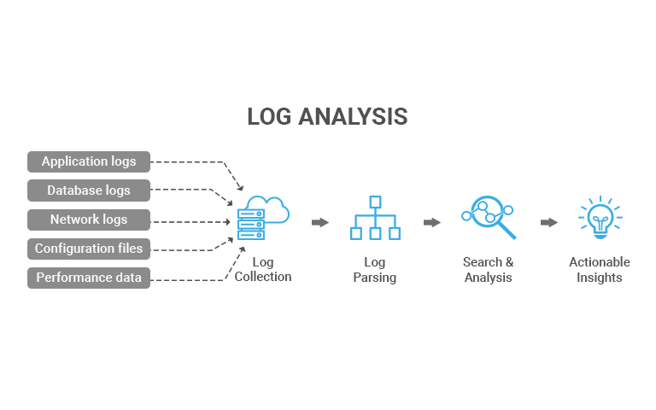

### First Step Data Collection:

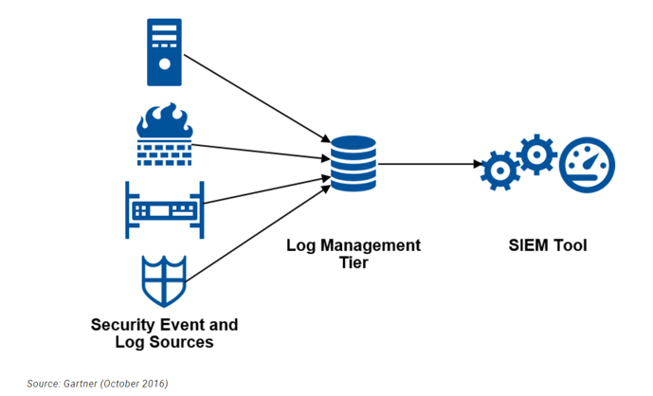

**We have provided a dataset with various attributes related to network traffic logs. Each row appears to represent a network connection, and the columns seem to describe different features of those connections. Here's a breakdown of the columns:**

**duration**: Duration of the connection in seconds.

**protocol_type**: Type of the protocol (e.g., TCP, UDP, ICMP).

**service:** Type of service or application.

**flag**: Status of the connection (e.g., normal, error, reset).

**src_bytes**: Number of bytes sent by the source.

**dst_bytes**: Number of bytes sent to the destination.

**land**: Indicates whether the connection is from/to the same host/port.

**wrong_fragment**: Number of "wrong" fragments (obsolete; often zero).

**urgent**: Number of urgent packets.

**hot**: Number of "hot" indicators (suspicious actions).

**num_failed_logins**: Number of failed login attempts.

**logged_in:** Indicates if the user is logged in.

**num_compromised**: Number of compromised conditions.

**root_shell**: Indicates if the root shell is obtained.

**su_attempted**: Indicates if "su" command attempted.

**num_root:** Number of "root" accesses.

**num_file_creations:** Number of file creation operations.

**num_shells:** Number of shell prompts.

**num_access_files:** Number of access files.

**num_outbound_cmds**: Number of outbound commands.

**is_host_login**: Indicates if login is host-based.

**is_guest_login:** Indicates if login is guest-based.

**count**: Number of connections to the same host as the current connection.

**srv_count**: Number of connections to the same service as the current connection.

**serror_rate**: Error rate for connections to the same host.

**srv_serror_rate**: Error rate for connections to the same service.

**rerror_rate:** Error rate for connections to the same host.

**srv_rerror_rate:** Error rate for connections to the same service.

**same_srv_rate:** Percentage of connections to the same service.

**diff_srv_rate**: Percentage of connections to different services.

**srv_diff_host_rate**: Rate of connections to different hosts for the same service.

**dst_host_count**: Number of connections to the same destination host.

**dst_host_srv_count**: Number of connections to the same destination service.

**dst_host_same_srv_rate**: Percentage of connections to the same service on the destination host.

**dst_host_same_src_port_rate**: Percentage of connections from the same source port.

**dst_host_srv_diff_host_rate**: Rate of connections to different hosts for the same service on the destination host.

**dst_host_serror_rate:** Error rate for connections to the same destination host.

**dst_host_srv_serror_rate:** Error rate for connections to the same destination service.

**dst_host_rerror_rate**: Error rate for connections to the same destination host.

**dst_host_srv_rerror_rate**: Error rate for connections to the same destination service.

**class**: The classification of the network connection (e.g., normal, suspicious, attack).

**This Figure Represent the Train_data.csv**

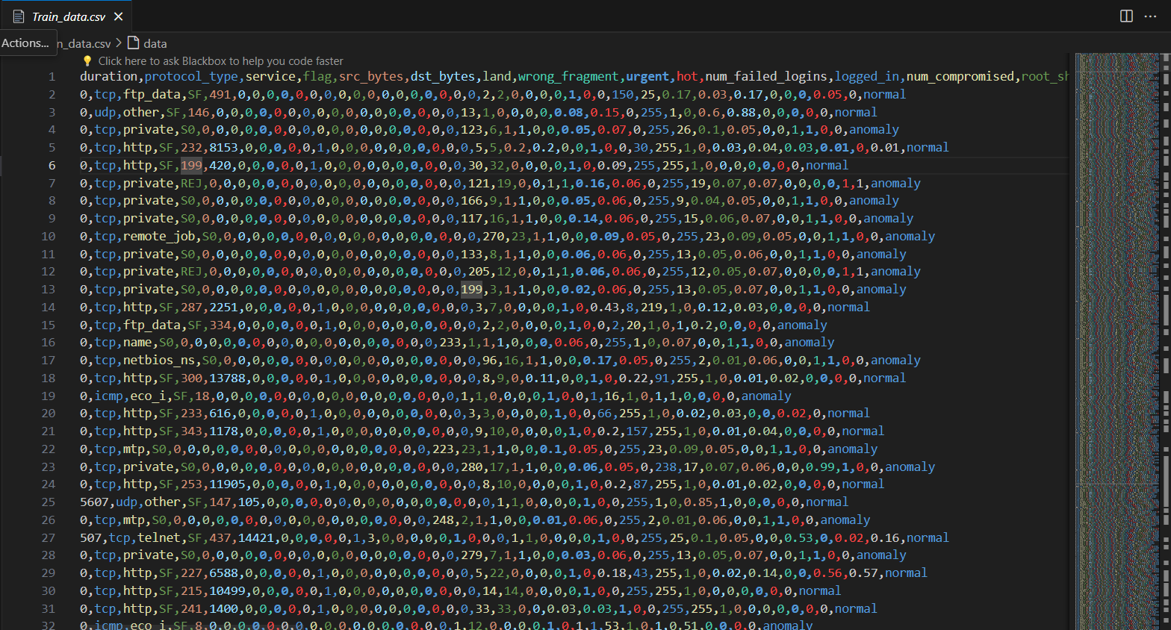

### **Second Step Data Preprocessing & Feature Engineering:**

### 

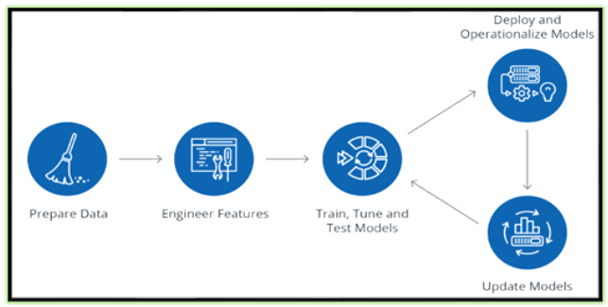

* **We have Created Python Project**
  + Importing Libraries: This imports various libraries used for data manipulation, visualization, machine learning models, and performance evaluation.

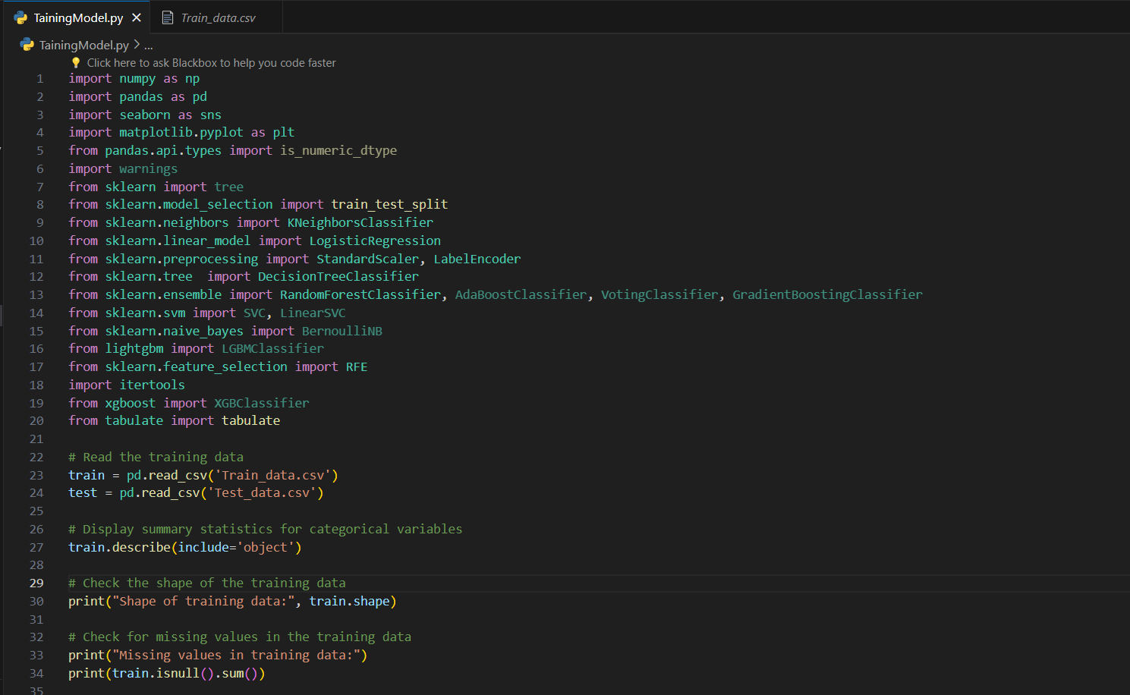

* **In this figure we have** 
  + Read the Training data
  + Display summary statistics for categorical variables
  + Check the shape of the training data
    - **Checking Shape**: This prints the shape (number of rows and columns) of the training dataset.
  + Check for missing values in the training data
    - **Checking Missing Values:** This checks for missing values in the training dataset and prints the sum of missing values for each column**.**

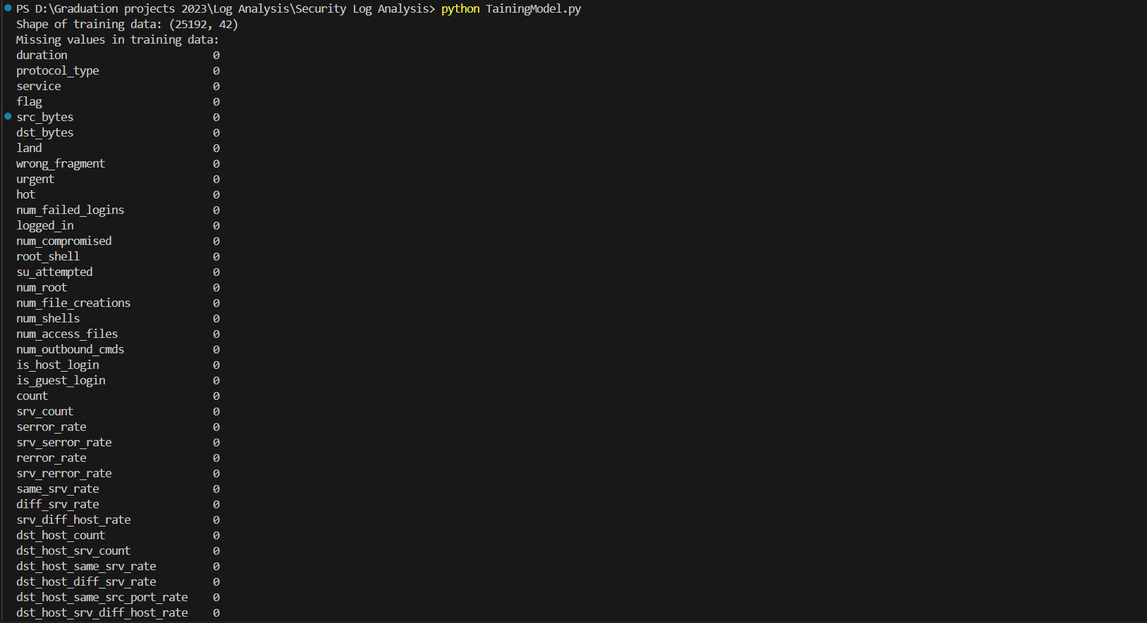

* **In this figure we have**
  + **Plot the distribution of the target variable 'class'**



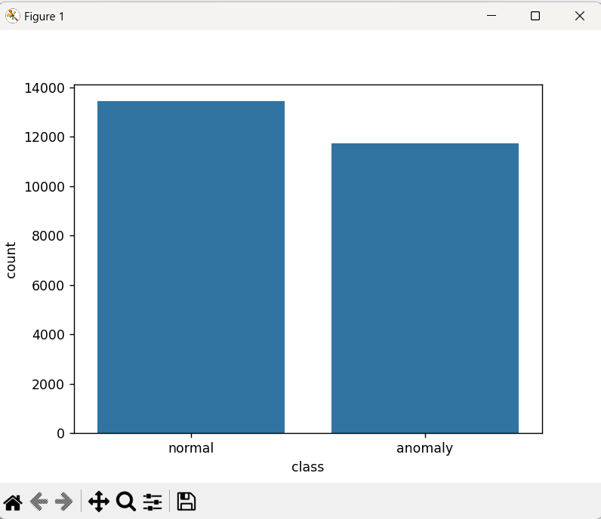

* **In this figure we have**
  + **Plot the distribution of the target variable ‘protocol type’**

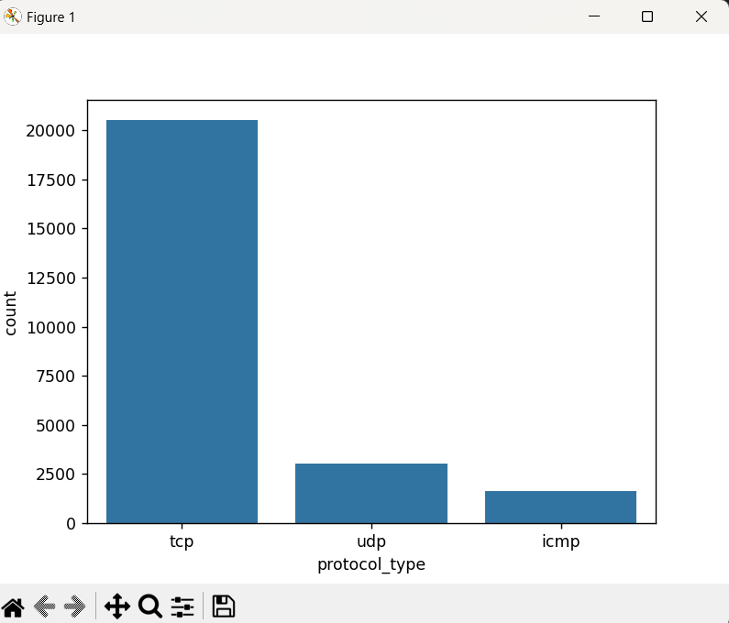

* **In this figure we have**
  + **Plot the distribution of the target variable ‘Service’**

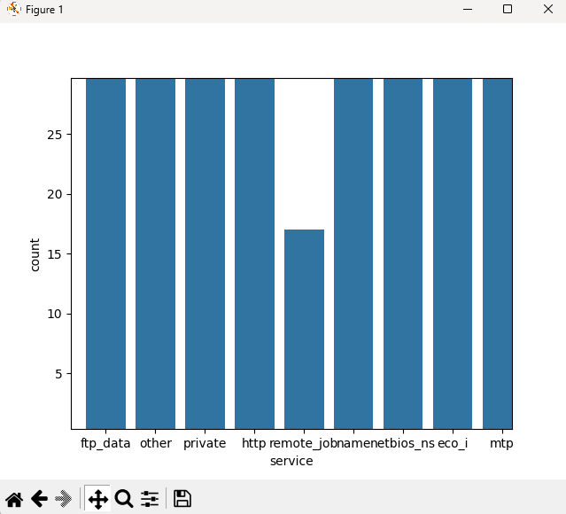

* **In this figure we have**
  + **Class Distribution**: This prints the class distribution of the target variable 'class' in the training dataset.
  + **Label Encoding**: This defines a function le() to encode categorical variables using LabelEncoder. It then applies this function to both the training and testing datasets.
  + **Removing Irrelevant Column:** This drops the column 'num_outbound_cmds' from both the training and testing datasets as it's considered irrelevant.
  + **Displaying First Few Rows:** This prints the first few rows of the preprocessed training dataset to verify the changes.

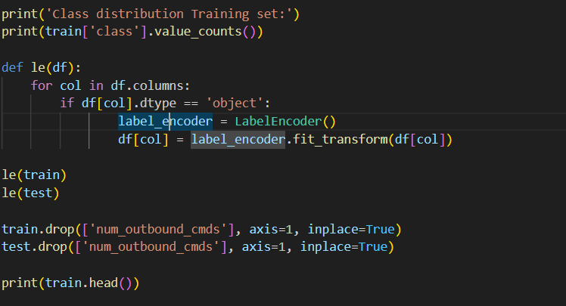

**Random Forest Classifier**

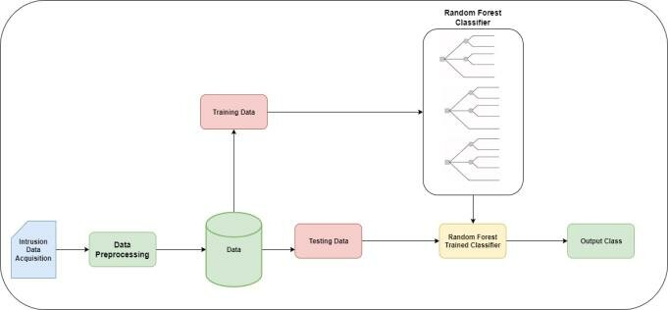

* **In this figure we have**
  + **Feature and Target Variable Separation:** This separates the features (independent variables) and the target variable 'class' from the training dataset.



* **In this figure we have**
  + **Initializing Random Forest Classifier**: This initializes a Random Forest Classifier.
  + **Feature Selection with RFE**: This initializes RFE with the Random Forest Classifier and specifies to select 10 features. It then fits RFE to the training data to select the best features.
  + **Selecting Features**: This creates feature map to map selected features to their indices, and then collects the selected features based on the RFE rankings.

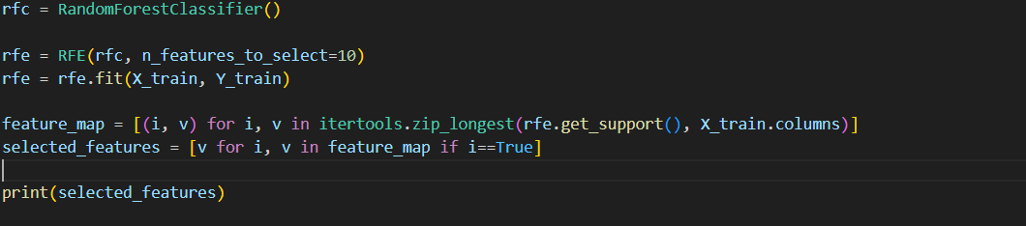

* + **Printing Selected Features**: This prints the list of selected features identified by the RFE process.



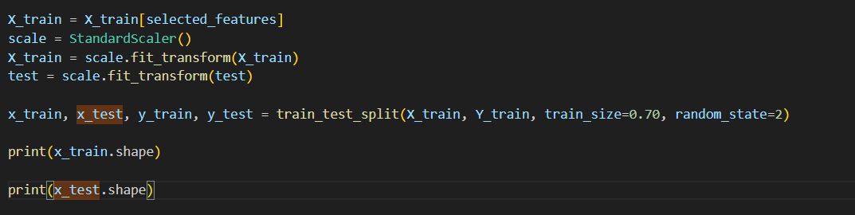

* **In this figure we have**
  + **Feature Selection and Scaling:**
    - X_train = X_train[selected_features]: Selects a specific set of features from the training data.
    - scale = StandardScaler(): Initializes a StandardScaler object, which is used to scale the features.
    - X_train = scale.fit_transform(X_train): Fits the scaler to the training data and then transforms it, scaling the selected features.
    - test = scale.fit_transform(test): It's important to note that here fit_transform() is called again on the test data. This should typically be transform() instead of fit_transform(), as you don't want to refit the scaler on the test data
  + **Train-Test Split:**
    - train_test_split(): Splits the data into training and testing sets. Here, 70% of the data is allocated for training (train_size=0.70), and the remaining 30% is allocated for testing.
    - random_state=2: Sets the random seed for reproducibility.
  + **Printing the Shapes:**
    - print(x_train.shape): Prints the shape (dimensions) of the training features.
    - print(x_test.shape): Prints the shape of the testing features.
    - The printed shapes will give you an idea of how the data is split between training and testing sets.



**K - nearest neighbor algorithm in machine learning**

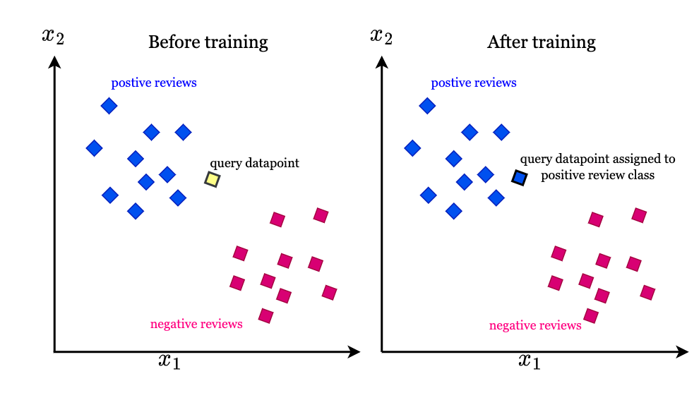

* **In this Code we Have :** 
  + **KNN Model Training and Testing:** This code trains a K-Nearest Neighbors (KNN) model with the best hyperparameters found using Optuna and evaluates its performance on the training and testing sets
  + **Hyperparameter Tuning with Optuna for KNN:** This code uses Optuna to perform hyperparameter tuning for the K-Nearest Neighbors **(KNN) model**. It defines an objective function that takes a trial object and suggests a value for the number of neighbors parameter (**n_neighbors**). The study object is then created to maximize the accuracy of the model, and the **optimize**() method is called to find the best hyperparameters. Finally, it prints the best trial.

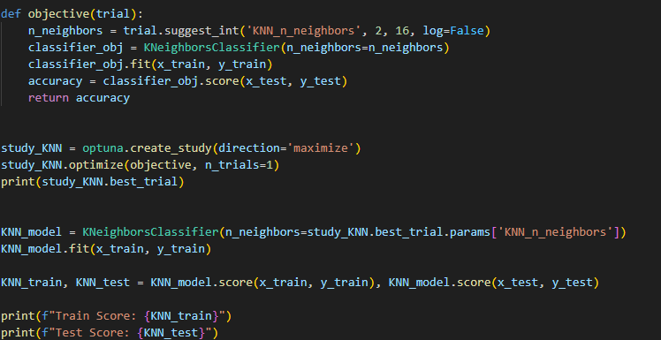

**Logistic Regression Algorithm**

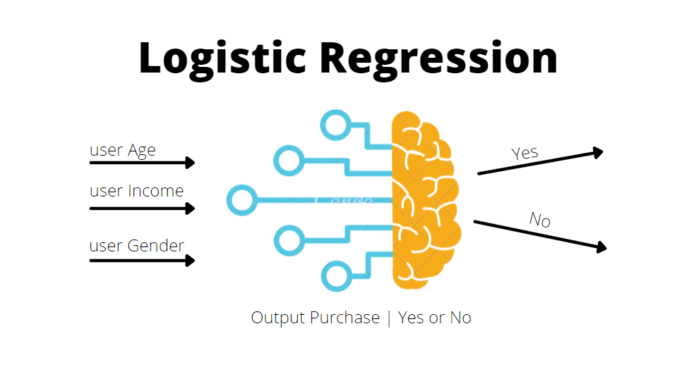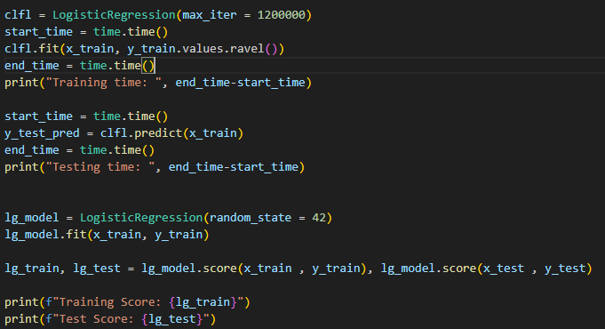

* **We have in this Code** 
  + **Logistic Regression Model Training and Testing**: This trains a Logistic Regression model and measures the training and testing time.

**Decision Tree Classifier**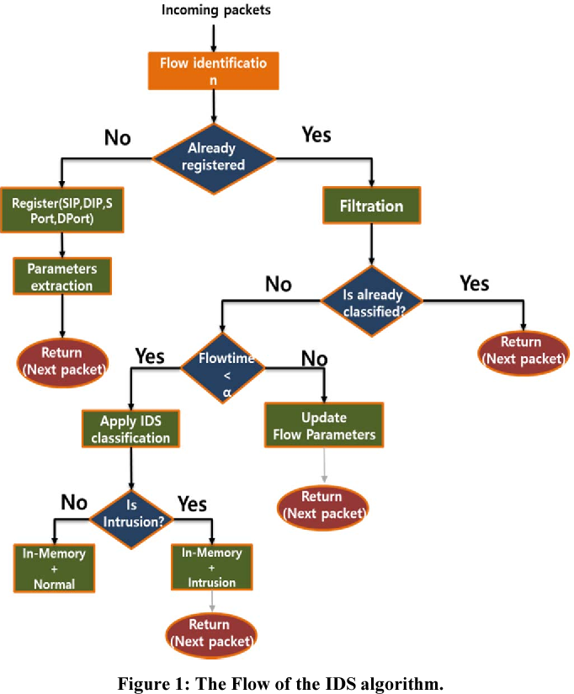

* **We have in this Figure** 
  + **Model** **Comparison**: This code creates a table using the **tabulate** library to display the training and testing scores of different models (KNN, Logistic Regression, and Decision Tree) in a tabular format.

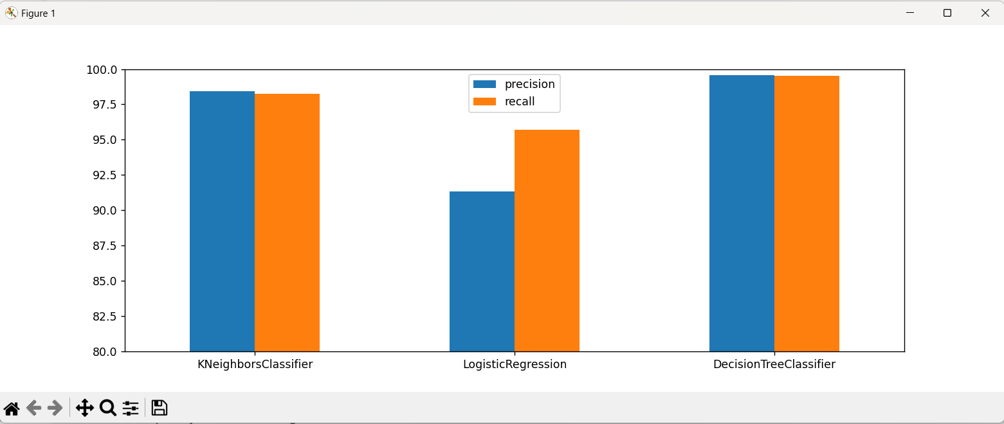

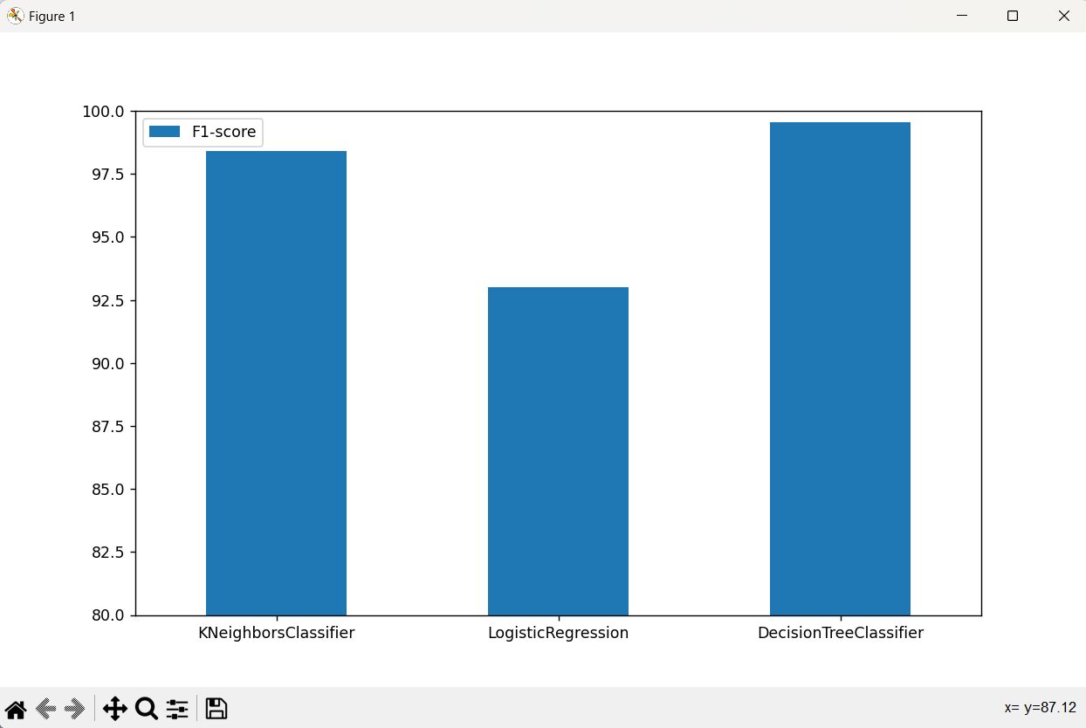

**3. Chapter summary**

The project progresses through data collection of network traffic logs, followed by preprocessing and feature engineering to prepare the data. Various machine learning algorithms, including Random Forest, KNN, Logistic Regression, and Decision Tree, are implemented for anomaly detection. Hyperparameter tuning is performed using Optuna to optimize model performance. Finally, model evaluation is conducted to compare and select the most effective approach for cybersecurity enhancement.

**CHAPTER III. VALIDATION**

**(Implementing and testing the solution)**

**1. Introduction**

The development of a robust anomaly detection system for cybersecurity requires a multifaceted approach, encompassing both frontend and backend technologies as well as leveraging machine learning techniques. This project aims to provide a comprehensive solution by integrating various tools and programming languages to address the challenges associated with anomaly detection within log data.

**Tools and Programming Languages**

**Frontend(HTML-CSS-JavaScript)**

**Backend(Flask or Django-Machine Learning)**

**1. FrontEnd :**

* **HTML:** HyperText Markup Language is used for structuring the web page.
* **CSS:** Cascading Style Sheets are used for styling the HTML elements and adding visual enhancements.
* **JavaScript**: A scripting language used to add interactivity to web pages. In this case, JavaScript is used to handle form submission, make AJAX requests to the server, update the progress bar, and handle button clicks.
* **jQuery**: A fast, small, and feature-rich JavaScript library. It simplifies things like HTML document traversal and manipulation, event handling, and animation. In this code, jQuery is used for DOM manipulation, event handling, and AJAX requests.
* **Bootstrap**: A popular CSS framework used for designing responsive and mobile-first websites. It provides pre-designed CSS styles and JavaScript plugins for creating responsive layouts and components. In this code, Bootstrap is used for styling the form elements and adding progress bars.
* **Font Awesome**: A font and icon toolkit based on CSS and LESS. It provides scalable vector icons that can be customized with CSS. In this code, Font Awesome is used for adding icons to various elements in the web page.

**2. Back End :**

* **Flask or Django:** These are popular Python web frameworks used for building web applications. In this case, it's likely that Flask is being used due to its simplicity and lightweight nature. Flask allows you to create web applications and APIs easily.
* **Scikit-learn:** This is a widely-used Python library for machine learning. It provides simple and efficient tools for data mining and data analysis. In the context of the provided code, Scikit-learn could be used to train a machine learning model for anomaly detection based on the provided input data.
* **Pandas:** Pandas is another Python library often used in conjunction with Scikit-learn for data preprocessing and manipulation. It provides data structures andfunctionsto work with structured data, which could be helpful in preparing the input data for training the machine learning model.
* **NumPy:** NumPy is a fundamental package for scientific computing with Python. It provides support for large, multi-dimensional arrays and matrices, along with a collection of mathematical functions to operate on these arrays. NumPy could be used for numerical computations involved in data preprocessing and feature engineering.
* **Matplotlib :** These are Python libraries used for data visualization. They provide functions to create various types of plots and charts, which could be useful for analyzing the data before and after training the machine learning model.

**2. Hardware and software environment**

**FrontEnd UI Test WebSite**

* We have made a Flask API Using Python

**Api.py**

from flask import Flask, request, jsonify

import pandas as pd

import joblib

import webbrowser

from flask_cors import CORS

app = Flask(__name__)

CORS(app, resources={r"/predict": {"origins": "*"}})  # Allow CORS for '/predict' endpoint from all origins

# Load the trained model

model = joblib.load('DecisionTreeClassifier.pkl')

webbrowser.open_new_tab('index.html')

@app.route('/predict', methods=['POST'])

def predict():

    # Get the request data

    data = request.get_json()

    # Convert the JSON data to a DataFrame with a default index

    df = pd.DataFrame(data, index=[0])

    # Encode categorical variables

    df_encoded = pd.get_dummies(df)  # Assuming one-hot encoding

    # Make predictions

    predictions = model.predict(df_encoded)

    # Return the predictions as JSON

    return jsonify({'predictions': predictions.tolist()})

if __name__ == '__main__':

    app.run(debug=True, port=5002)

**Index .html**

<!DOCTYPE html>

<html lang="en">

<head>

    <meta charset="UTF-8">

    <meta name="viewport" content="width=device-width, initial-scale=1.0">

    <title>Anomaly Detection</title>

    <!-- Bootstrap CSS -->

    <link rel="stylesheet" href="https://stackpath.bootstrapcdn.com/bootstrap/4.5.2/css/bootstrap.min.css">

    <!-- Font Awesome for icons -->

    <link rel="stylesheet" href="https://cdnjs.cloudflare.com/ajax/libs/font-awesome/5.15.4/css/all.min.css">

    <!-- Custom CSS for animation -->

    <style>

        body {

            background-image: url('bg.jpeg');

            color: white

        }

        .progress-bar {

            background-color: #28a745;

        }

        @keyframes fadeInOut {

            0% {

                opacity: 0;

            }

            50% {

                opacity: 1;

            }

            100% {

                opacity: 0;

            }

        }

        .animate-fade-in-out {

            animation: fadeInOut 2s infinite;

        }

        /* Style for the prediction result */

        #predictionResult {

            font-size: 35px;

            text-align: center;

            font-weight: bold;

            margin-top: 20px;

        }

    </style>

</head>

<body>

    <div class="container mt-5">

        <h1 class="mb-4 text-center">Network Security Log Detection</h1>

        <div class="progress mt-2" style="display: none;">

            <div id="progressBar" class="progress-bar" role="progressbar" style="width: 0%;" aria-valuenow="0"

                aria-valuemin="0" aria-valuemax="100"></div>

        </div>

        <form id="predictionForm">

            <div class="row">

                <div class="col-md-6">

                    <div class="form-group">

                        <label for="duration">

                            <i class="fas fa-stopwatch"></i> Duration:

                        </label>

                        <input type="number" class="form-control" id="duration" name="duration" value="0" required>

                    </div>

                    <div class="form-group">

                        <label for="protocol_type">

                            <i class="fas fa-network-wired"></i> Protocol Type:

                        </label>

                        <select class="form-control" id="protocol_type" name="protocol_type" required>

                            <option value="tcp">tcp</option>

                            <option value="icmp">icmp</option>

                            <option value="udp">udp</option>

                        </select>

                    </div>

                </div>

                <div class="col-md-6">

                    <div class="form-group">

                        <label for="service">

                            <i class="fas fa-server"></i> Service:

                        </label>

                        <select class="form-control" id="service" name="service" required>

                            <option value="mtp">mtp</option>

                            <option value="private">private</option>

                            <option value="ftp_data">ftp_data</option>

                            <option value="eco_i">eco_i</option>

                            <option value="telnet">telnet</option>

                            <option value="http">http</option>

                            <option value="smtp">smtp</option>

                            <option value="ldap">ldap</option>

                            <option value="pop_3">pop_3</option>

                            <option value="courier">courier</option>

                            <option value="imap4">imap4</option>

                            <option value="domain_u">domain_u</option>

                        </select>

                    </div>

                    <div class="form-group">

                        <label for="flag">

                            <i class="fas fa-flag"></i> Flag:

                        </label>

                        <select class="form-control" id="flag" name="flag" required>

                            <option value="REJ">REJ</option>

                            <option value="SF">SF</option>

                            <option value="RSTO">RSTO</option>

                            <option value="S0">S0</option>

                            <option value="RSTR">RSTR</option>

                        </select>

                    </div>

                </div>

            </div>

            <div class="row">

                <div class="col-md-6">

                    <div class="form-group">

                        <label for="src_bytes">

                            <i class="fas fa-arrow-up"></i> Source Bytes:

                        </label>

                        <input type="number" class="form-control" id="src_bytes" name="src_bytes" value="0" required>

                    </div>

                    <div class="form-group">

                        <label for="dst_bytes">

                            <i class="fas fa-arrow-down"></i> Destination Bytes:

                        </label>

                        <input type="number" class="form-control" id="dst_bytes" name="dst_bytes" value="0" required>

                    </div>

                </div>

                <div class="col-md-6">

                    <div class="form-group">

                        <label for="land">

                            <i class="fas fa-landmark"></i> Land:

                        </label>

                        <input type="number" class="form-control" id="land" name="land" value="0" required>

                    </div>

                    <div class="form-group">

                        <label for="wrong_fragment">

                            <i class="fas fa-times"></i> Wrong Fragment:

                        </label>

                        <input type="number" class="form-control" id="wrong_fragment" name="wrong_fragment" value="0"

                            required>

                    </div>

                </div>

            </div>

            <div class="row">

                <div class="col-md-6">

                    <div class="form-group">

                        <label for="urgent">

                            <i class="fas fa-exclamation-triangle"></i> Urgent:

                        </label>

                        <input type="number" class="form-control" id="urgent" name="urgent" value="0" required>

                    </div>

                </div>

                <div class="col-md-6">

                    <div class="form-group">

                        <label for="hot">

                            <i class="fas fa-fire"></i> Hot:

                        </label>

                        <input type="number" class="form-control" id="hot" name="hot" value="0" required>

                    </div>

                </div>

            </div>

            <!-- Display prediction result here -->

            <div id="predictionResult"></div>

            <!-- Button for submitting the form -->

            <div class="text-center">

                <div class="center-button">

                    <button type="submit" id="predictButton" class="btn btn-success">

                        <i class="fas fa-robot"></i> Predict Log From AI Model

                        <span id="countdown" style="margin-left: 10px;"></span>

                    </button>

                    <button type="button" id="resetButton" class="btn btn-danger ml-3" style="display: none;">

                        <i class="fas fa-times-circle"></i> Reset

                    </button>

                </div>

            </div>

        </form>

    </div>

    <!-- Bootstrap JS -->

    <script src="https://code.jquery.com/jquery-3.5.1.min.js"></script>

    <script src="https://cdn.jsdelivr.net/npm/@popperjs/core@2.5.4/dist/umd/popper.min.js"></script>

    <script src="https://stackpath.bootstrapcdn.com/bootstrap/4.5.2/js/bootstrap.min.js"></script>

    <!-- Your custom JavaScript -->

    <script>

        $(document).ready(function () {

            $('#predictionForm').submit(function (event) {

                event.preventDefault(); // Prevent the form from submitting normally

                // Get form data

                var duration = parseInt($('#duration').val());

                var protocol_type = [$('#protocol_type').val()];

                var service = [$('#service').val()];

                var flag = [$('#flag').val()];

                var src_bytes = parseInt($('#src_bytes').val());

                var dst_bytes = parseInt($('#dst_bytes').val());

                var land = parseInt($('#land').val());

                var wrong_fragment = parseInt($('#wrong_fragment').val());

                var urgent = parseInt($('#urgent').val());

                var hot = parseInt($('#hot').val());

                var jsonData = {

                    "duration": [duration],

                    "protocol_type": protocol_type,

                    "service": service,

                    "flag": flag,

                    "src_bytes": [src_bytes],

                    "dst_bytes": [dst_bytes],

                    "land": [land],

                    "wrong_fragment": [wrong_fragment],

                    "urgent": [urgent],

                    "hot": [hot]

                };

                console.log(JSON.stringify(jsonData));

                console.log("JSON Data: ", jsonData);

                $('#predictButton').prop('disabled', true);

                $('.progress').show();

                $('#resetButton').hide();

                var progressBar = $('#progressBar');

                var countdown = 10;

                var interval = setInterval(function () {

                    progressBar.css('width', ((10 - countdown) * 10) + '%');

                    progressBar.attr('aria-valuenow', (10 - countdown) * 10);

                    $('#countdown').text(countdown);

                    countdown--;

                    if (countdown < 0) {

                        clearInterval(interval);

                        progressBar.css('width', '100%');

                        $.ajax({

                            url: 'http://localhost:5002/predict',

                            type: 'POST',

                            contentType: 'application/json',

                            data: JSON.stringify(jsonData),

                            success: function (response) {

                                var resultDiv = $('#predictionResult');

                                if (response.predictions[0] === 1) {

                                    resultDiv.text('Prediction: Normal Log').addClass('text-success');

                                } else {

                                    resultDiv.text('Prediction: Anomaly Log').addClass('text-danger');

                                }

                                resultDiv.addClass('animate-fade-in-out');

                                $('#resetButton').show();

                            },

                            error: function (xhr, status, error) {

                                alert('Error: ' + error);

                            }

                        });

                    }

                }, 1000);

            });

            $('#resetButton').click(function () {

                $('.progress').hide();

                $('#predictButton').prop('disabled', false);

                $('#predictionResult').empty().removeClass('text-success text-danger animate-fade-in-out');

                $('#resetButton').hide();

            });

        });

    </script>

</body>

</html>

**ScreenShoot of App Testing**

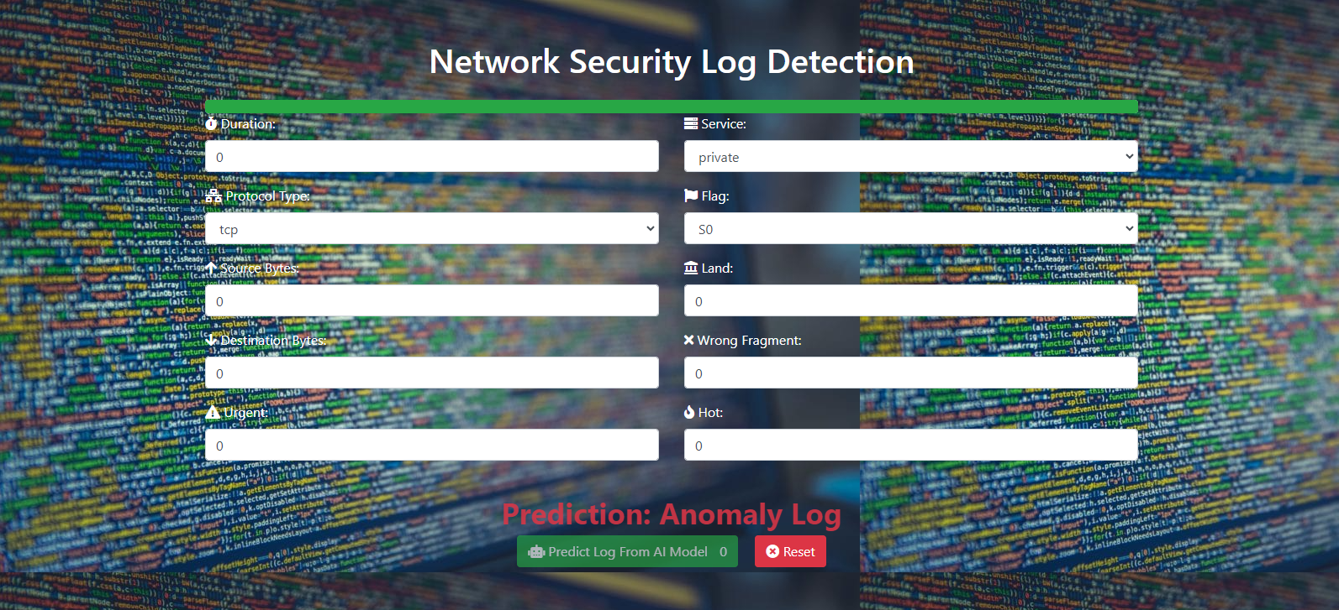

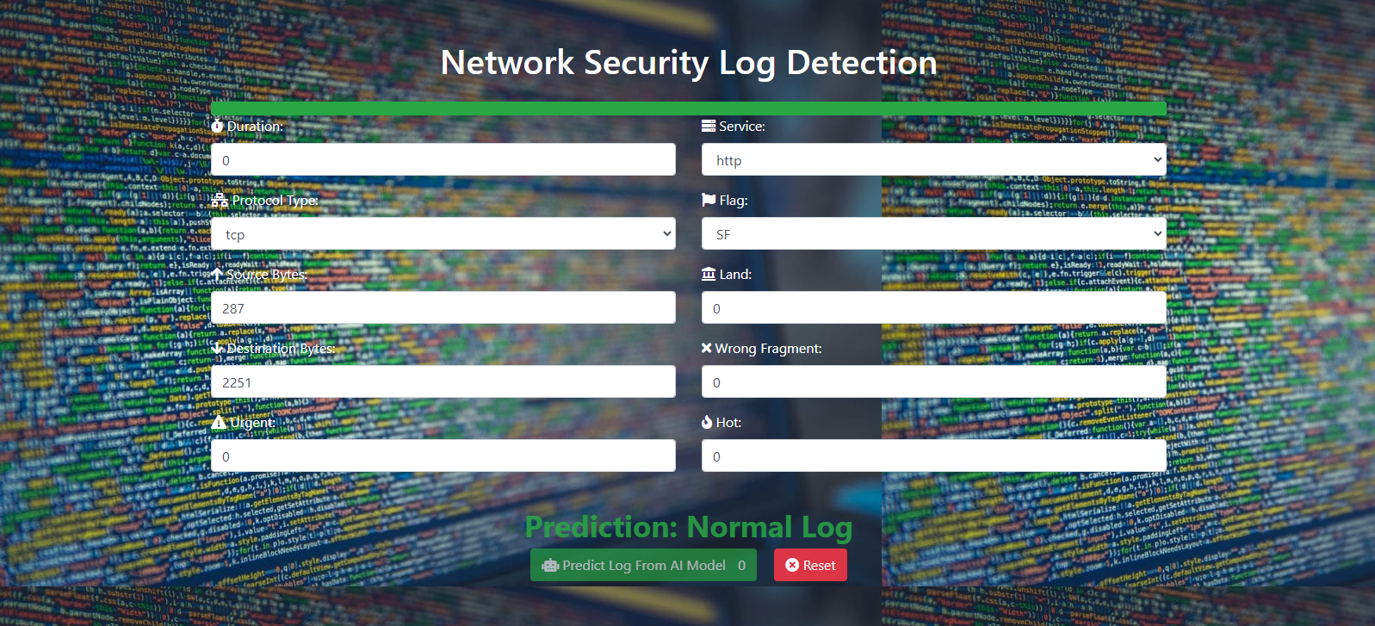

**SUMMARY**

The general conclusion section of a manuscript serves as the final part of the document, summarizing the key findings, discussing their implications, and providing closure to the research or study. Here's how the general conclusion section might be structured:

**1. Objectives revisited**

This section serves the purpose of revisiting the objectives set forth earlier in the graduation project and evaluating how well they have been achieved. First, the restatement of objectives should be related to the project's main topic and needs. Then, an evaluation of the obtained results (e.g., a designed network architecture) is conducted by a comparison to the initial expectations of the project team and his supervisor.

**2. Challenges and future work**

A discussion of the current solution's limitations helps identify, not only the lessons learned but also the future work and the possible improvement of the proposed solution. For example, the implementation of additional functionalities or the instantiation of the solution to various scenarios or domains may be part of the project’s future improvements.

For example, students can identify the following future challenges and emerging trends, when their project deals with secure network design: IoT and BYOD security, Cloud-native security, AI and machine learning for threat detection, and Quantum-safe cryptography.

**REFERENCES**

In a graduation project, the reference section is a critical component that provides a comprehensive list of all the sources cited or consulted during the research process. This section typically appears at the end of the project and follows a specific formatting style, such as APA, MLA, etc.

References cover various sources commonly used in graduation projects, including a thesis, journal article, book, and conference paper. Make sure to adapt the formatting and content according to the specific requirements and sources used in your project.

References in graduation projects typically follow a specific formatting style. Examples include:

* Smith, A. (2021). Understanding the role of artificial intelligence in cybersecurity. Journal of Cybersecurity Research, 5(2), 123-135. <https://doi.org/10.1234/jcr.2021.1234>
* Johnson, B. (2019). Cybersecurity best practices for small and medium-sized enterprises. New York, NY: TechPublishing.
* Garcia, C., & Martinez, D. (2020). Secure network architecture for smart buildings. In A. Editor & B. Editor (Eds.), Proceedings of the International Conference on Cybersecurity (pp. 45-56). Springer. Retrieved from <https://www.example.com/proceedings-cybersecurity-conference>

**APPENDICES**

In a graduation project, an appendix is a supplementary section that contains additional material relevant to the project but not included in the main body of the document. The appendix typically appears after the reference section and may include items such as raw data, charts, tables, questionnaires, code samples, or additional documentation that supports the findings or arguments presented in the main text.

Here is an example of an appendix:

|  |
| --- |
| Appendix A: Network Diagrams  This appendix contains detailed network diagrams illustrating the architecture and topology of the proposed network infrastructure.  Network Diagram 1: Wireless Access Points Placement  This diagram shows the placement and coverage areas of wireless access points (WAPs) throughout the physical space, ensuring adequate Wi-Fi coverage and signal strength.  [Insert image of the wireless access points placement diagram here]  Network Diagram 2: VLAN Configuration  This diagram outlines the configuration of virtual LANs (VLANs) within the network, illustrating how different departments or groups are segmented for security and performance reasons.  [Insert image of the VLAN configuration diagram here] |